Investigating productivity-compensation decoupling across industries and income levels.

In modern, developed economies, there has been emerging a branch of literature related to the decoupling of labour productivity and compensation across time. The trend is broadly that labour productivity has risen consistently year-over-year, while median compensation has begun to stagnate, remaining fairly flat across several time periods in recent years.

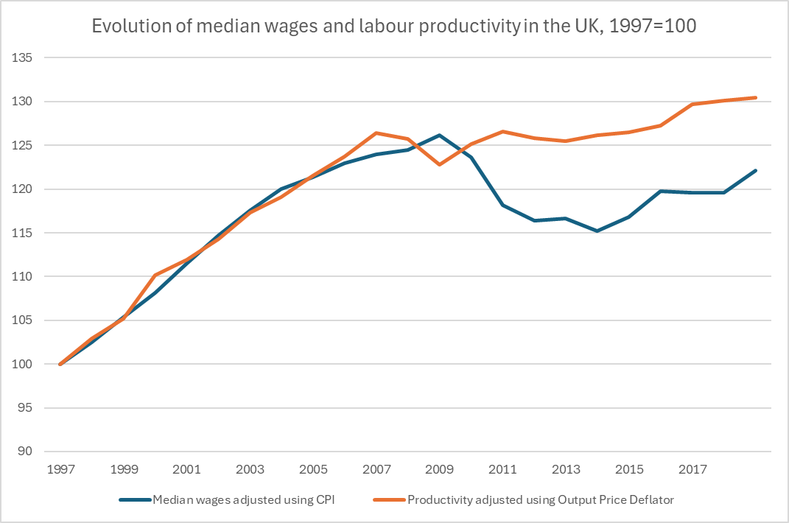

Figure – Median wages sourced from ASHE Table 4.5a 1997-2019, Productivity from ONS Blue Book 2023

Tracking growth rates through indices is common practice in the literature (Brill2017; Fleck2011; VanReenen2013; Teichgraeber2021), although it may create a distorted picture of when exactly productivity and compensation have decoupled. Figure 1 shows the relative growth of average productivity and median wages (differences in compensation measures will be discussed later) from 1997, however starting the time series earlier will paint a different picture of decoupling in the UK; Pessoa & Van Reenen (2013) catalogue changes from 1948 and identify the decoupling point around 1992,

Pessoa & Van Reenen (2013) introduce a distinction between ‘net’ and ‘gross’ decoupling, where net decoupling represents an underlying change to the labour share of income, whereas gross decoupling instead